Tanner Day
11/12/13
Roberts – M/W 10:00-11:20
Proposal: College Football BCS/Playoff System

Tradition vs. Contention
Introduction:
In college football, the post season format is currently structured as a bowl system. The bowl system containing 35 games has been around since we can all remember. Having 70 spots available for teams to play in bowl games gives every school something to fight for and look forward to in the post season. Football fans are crazy about football in the winter because it means they get to watch their teams compete for something they have worked all year for, whether it is a national championship or something as minor as a Little Caesar’s bowl game. However, every year there seems to be controversy as to which teams get into the glorified BCS bowl games, the National Championship in particular.
The Problem:
In today’s college football system, there are more teams that could closely compete for a national championship and a large number of schools feel they deserve the opportunity to be in contention. Compare this to back in the day when there would be only a few powerhouse teams that deserved to play in the championship game and you can see how the controversy has piled up recently. In the beginning, bowl games were added so that a large portion of schools could have the pleasure performing in the post season. But is the portion size to large? A sports analyst from bleacherreport.com states,
As for the 35 games themselves, the issue is a double-edged sword for me. I fully realize that this is probably WAY too many bowl games. Seventy of 120 teams going bowling is excessive. Will 70 even be bowl eligible?
Aside from the fact that there are too many college football teams playing in December, another problem is that there are teams well worthy of playing in the championship game but never get the chance, which is usually determined by which conference they belong to. It is nearly impossible to compare teams to one another merely based on the speculation of their schedule “difficulty”. A prime example of this kind of common quarrel is when Urban Meyer led the Utah Utes to a perfect season in 2004 and his team was not even in the discussion for the national championship game. Every year there are one or two teams that go undefeated but are not even looked at as a national championship contender.
The Solution:
Taking into consideration the almost pointless number of bowl games and questionable BCS bowl game system, the idea of a BCS playoff system has surfaced many minds. A playoff system has been clearly successful for college basketball, seeing how March Madness causes a craze every spring. However, a 64 team playoff in football would fail to hold strong because of the major gap in performance levels of the top and bottom teams. To prevent a waste of time, the best structure would seem to be a sixteen team playoff. While conducting topic based research I came across this information: According to a survey on cnnsi.com 82% of fans would like to see an 8 or 16 team playoff (ufl.edu). In addition to this statistic, figure 1 displays a poll
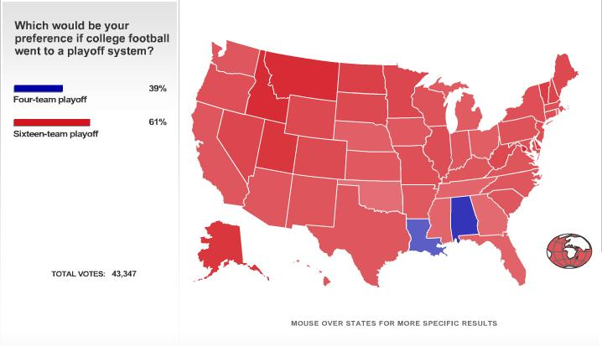
taken by ESPN, the worldwide leader in sports. It has become apparent that a sixteen team based playoff structure would be the best fit for the BCS. This change would provide the opportunity for teams that feel they are worthy contenders to prove to themselves and to the rest of the country that they are ready to take the next big step.
Figure 1
Planning:
The first eight matchups of this playoff system would be determined by the top 16 schools in the BCS poll at the end of the regular season. In the first round, the number 1 team would play the number 16 team; number 2 would play number 15, and so on until ranks 8 and 9 meet in the middle. Each school will face a win or go home situation in each round of the single game elimination bracket. This structure would take the top teams from all the major conferences (1st place in all BCS conferences and 5 wildcard spots) and give them their well-deserved shot at a national championship. The higher ranked team would have the home field advantage in every matchup until the national championship, which would be played in a neutral stadium/arena. Figure 2 displays the layout of the bracket.
Figure 2
Conclusion:
College football is and always will be about tradition. However, there are some things that could be improved by altering. Eliminating bowl games and importing a BCS playoff system is one of these things because the game has become advanced enough that it is hard to predict who the best teams are, unlike in past times. This could be the start of a new tradition that would carry on and please fans as well as college football organizations in many ways. Also, this would naturally generate more competition throughout the season with a reward of being selected to play in the post season. All of a sudden, the ultimate achievement of college football, a national championship, becomes a tangible goal for schools all across the nation.

Works Cited:
Carnival, Barking. "College Football: Are 35 bowl games too many?." bleacherreport.com. N.p., 9 May 2010. Web. 13 Nov 2013.
Varnadore, Bruce. "Will College Football Ever Have A Playoff." ufl.edu. N.p., n.d. Web. 14 Nov 2013.
Dyer, Kristian. "A 16 Team College Football Playoff." sports.yahoo/blogs. yahoo, 12 Dec 2012. Web. 16 Nov 2013.
Chi, Samuel. "Replacing College Football's 2012 Bowl Games." sbnation.com. SportsBeat, 10 Dec 2012. Web. 19 Nov 2013.

